A new testimony of healing

It is attributed to the intercession of Luisa “The Saint”

1/15/2016
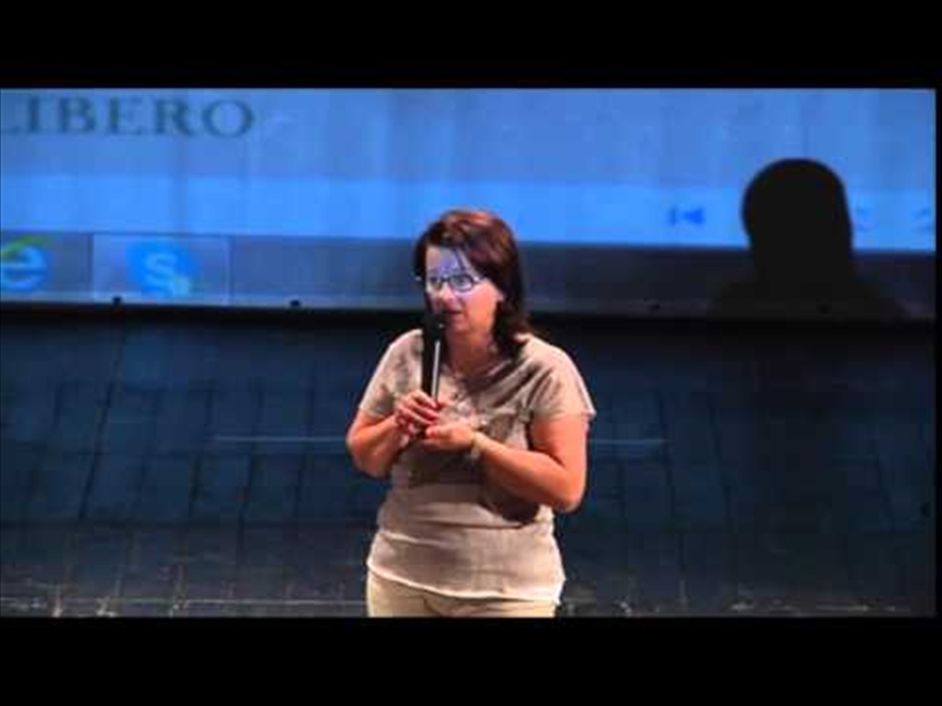
3 year old boy miraculously saved
A new testimony of healing attributed to Luisa “The Saint” was given during the Open Day, on June 14, 2015 and subsequently published by "Lo Stradone" newspaper from Corato. It is about a boy who was only 3 years old.
Who tells this poignant story is Mrs. C. R, the child's mother.
We start by saying that the family in question is not from Corato. They live in their home town Ruvo of Puglia, not far from Corato, but where the name of Luisa Piccarreta, at the time of the events, was not yet widespread.
Everything started between 2006 and 2007: the child was diagnosed with a sarcoma in the head for which he underwent three surgeries at close range of each other.
Upon awakening after the third surgery, the child said he had dreamt an old and perfumed lady. The family immediately thought of the sorrowful Virgin, most likely because of the child's health. Meanwhile, without their knowledge, some of their relatives began to entrust to the Little Daughter of the Divine Will their prayers.
After child’s dream there was that of a relative of theirs, the aunt of Mrs. C.’s husband: it was Luisa who said "it's all good for the child."
The reference was clear and the family decided to visit the house-museum of Luisa. My son was almost 4 years, and when he saw the picture of Luisa Piccarreta he immediately said to me:" 'This is the lady I dreamed! ", Mrs. C. continues " and from that moment we began to read up on Luisa ... for me the book The 24 Hours of the Passion has become my creed. "
There was still no mention of full recovery, the disease was very aggressive, but within the family the confidence in Luisa and her intercession was growing.
A new sign that Luisa had not been inactive during those years was given in 2014, when the family was invited by some friends to lunch in the countryside. Here are the exact words that Mrs. C. granted to "Lo Stradone" newspaper: "After lunch we went for a walk and our friends led us to “the Holy ". I did not think in any way of Luisa. Along the way, we found ourselves on a path, while the children (my son and the children of our friends) proceeded on the sides, in the cornfields.
At a certain point my son, who was 11, left the group and going farther than the others, he arrived early at the place. When we arrived we found him at the foot of the big mulberry tree where Luisa loved to pray and where there was a small and faded picture of Luisa. He stayed there for a while, he looked me and my husband in the eyes, without saying word. His look said: "I found Luisa!".
The reference area is "Torre Disperata", the place where the family of Luisa moved from spring to autumn in order to cultivate the land.
Together with his friends, the child picked some flowers and placed them in front of the picture of Luisa as a token of his affection and gratitude, but on the way back, he complained to his parents about “the absence of an altar or a crucifix showing the sacredness of that place. "
Today that child is a boy of 12 years old, very discreet, who, aware of the grace he received, has been keeping for years a relic of Luisa, as a treasure, under his pillow, being careful to put it back there, at each change of sheets.
This new testimony could help, along with others already published on this website, to speed up the cause of Beatification of Luisa Piccarreta, but it is not for us to decide.
Here below what don Sergio Pellegrini, assistant ecclesiastical of the association "Luisa Piccarreta Little Children of the Divine Will" said in an interview, last November, to “Lo Stradone” newspaper: "However we would need before an opinion of a medical specialist, then with the consent of the Holy See, the Archbishop could proceed with the canonical process, just as it will happen, in an extraordinary way, for the case of Ms Margarita Chavez who told her testimony on the last day of the conference. The process will begin in Florida in late November and will end in mid-January. The procedure for registering a testimony is long and very complex. For the time being as regards the history of Mrs C., we register that there was a grace.”

FIAT!
Riccardina

When Luisa was alive ...

an inexplicable healing

1/19/2016

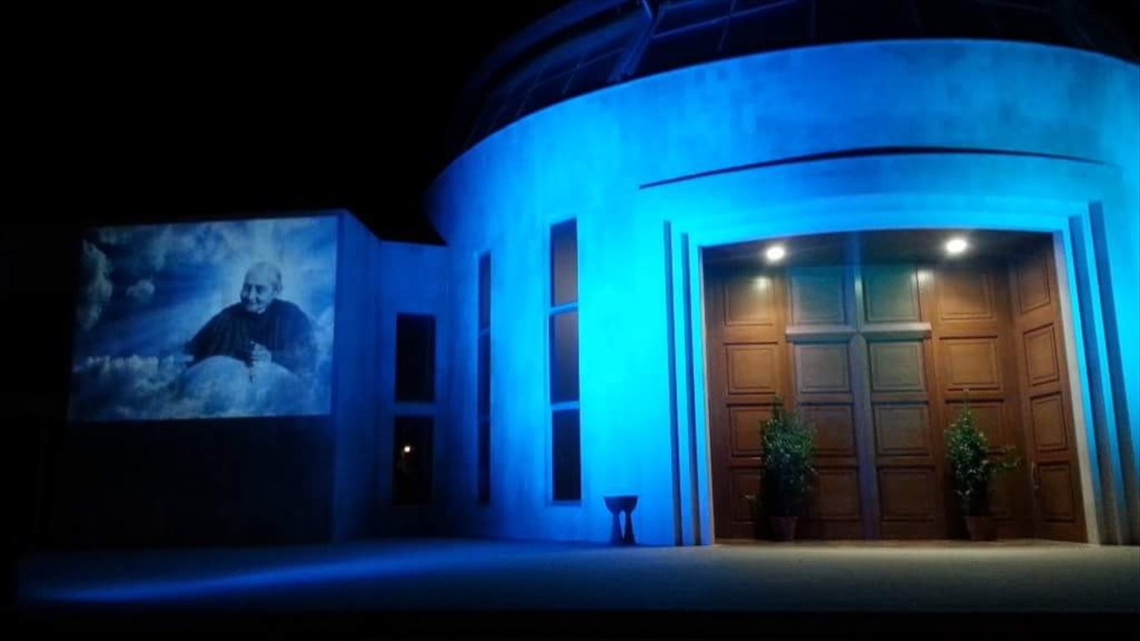
Another inexplicable healing obtained through the intercession of Luisa Piccarreta where the protagonist, this time, is one of Luisa’s fellow citizens.
The testimony is given directly by the person who experienced it and met Luisa during her illness. The event in fact takes place in the first half of the '30s when Mrs. L.M .was only three years old.
In full possession of her physical and mental abilities Mrs. L. remembers clearly what she learned from the story of her mother while she was alive and now, by a written document, she tells it our Association Little Children of the Divine Will for the collection of various statements of healing in favour of which Luisa interceded.
The story is as follows: when L. was very small, suddenly a swelling of considerable size was formed under her tongue and her parents took her to a surgeon.
The doctor said that she urgently need a surgical intervention so he fixed the surgery date. The girl was too little and for this reason her mother was scared and worried.
Perhaps it is no coincidence that her maternal grandmother had some relatives of Piccarreta as neighbors, in fact they after hearing the story and seeing the desperation of the young mother, suggested her taking the little girl to Luisa.
Luisa advised them not to operate on the little girl, but to entrust her to Saints Cosmas and Damian (medical saints) sure of their intercession, showing clearly her own devotion toward all the saints to whom, as a child, she addressed her prayers.
That very night from the little girl's mouth began to come out a kind of drool and the swelling began lowly to decrease until it disappeared altogether and didn’t occur anymore: the little girl was totally healed and grew very well.
At the end of her testimony, Ms L. wrote: "My mother told me that through the intercession of Luisa Piccarreta I received a miracle. From then until her death my mother was devoted to Luisa, and the Medical Saints; after her, I too! ".
A new miracle was accomplished thanks to the intercession of Luisa "The Holy" while she was still alive. There are in fact some events that happened proving the "gift of foresight" that Luisa had and they are described well in the Official Biography " The Sun of My Will", as well as it is not unusual her intercession in favour of little children toward whom she showed a special tenderness.
Many are those who still retain a sweet childhood memory of Luisa for having visited her with their own grandparents or parents, not always to receive a miracle, but for the simple love with which she used to welcome little children.
FIAT!
Riccardina

